**Name: Shivani Dixit**

**Panel: E**

**Batch: E1**

**PRN: 1032222352**

**Roll no.: 20**

**Problem Statement:**

Use HTML, CSS(No Bootstrap) and JavaScript to create an attractive(CSS) and interactive(JS) New Student Registration form for MITWPU.

[You can choose the fields or refer to any existing forms online]

**Screenshots:**

1.Opening View of website:

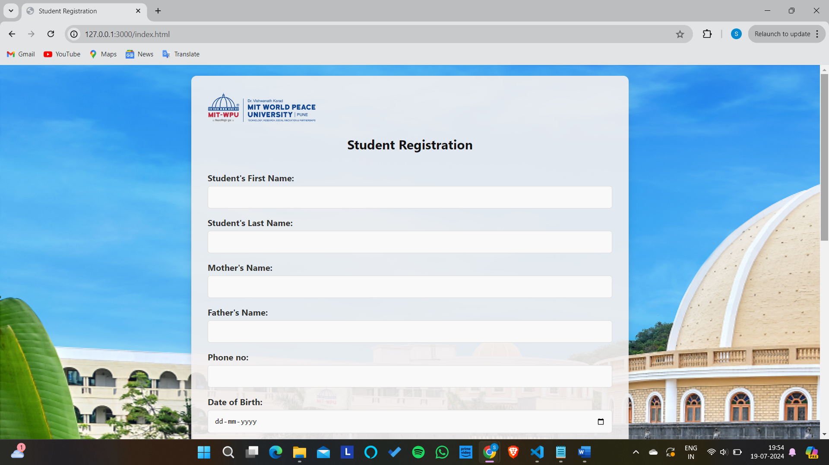

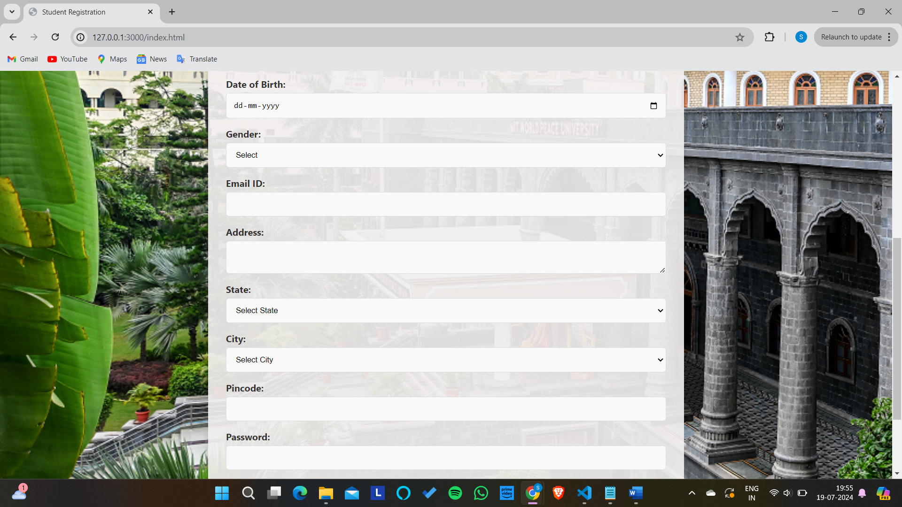

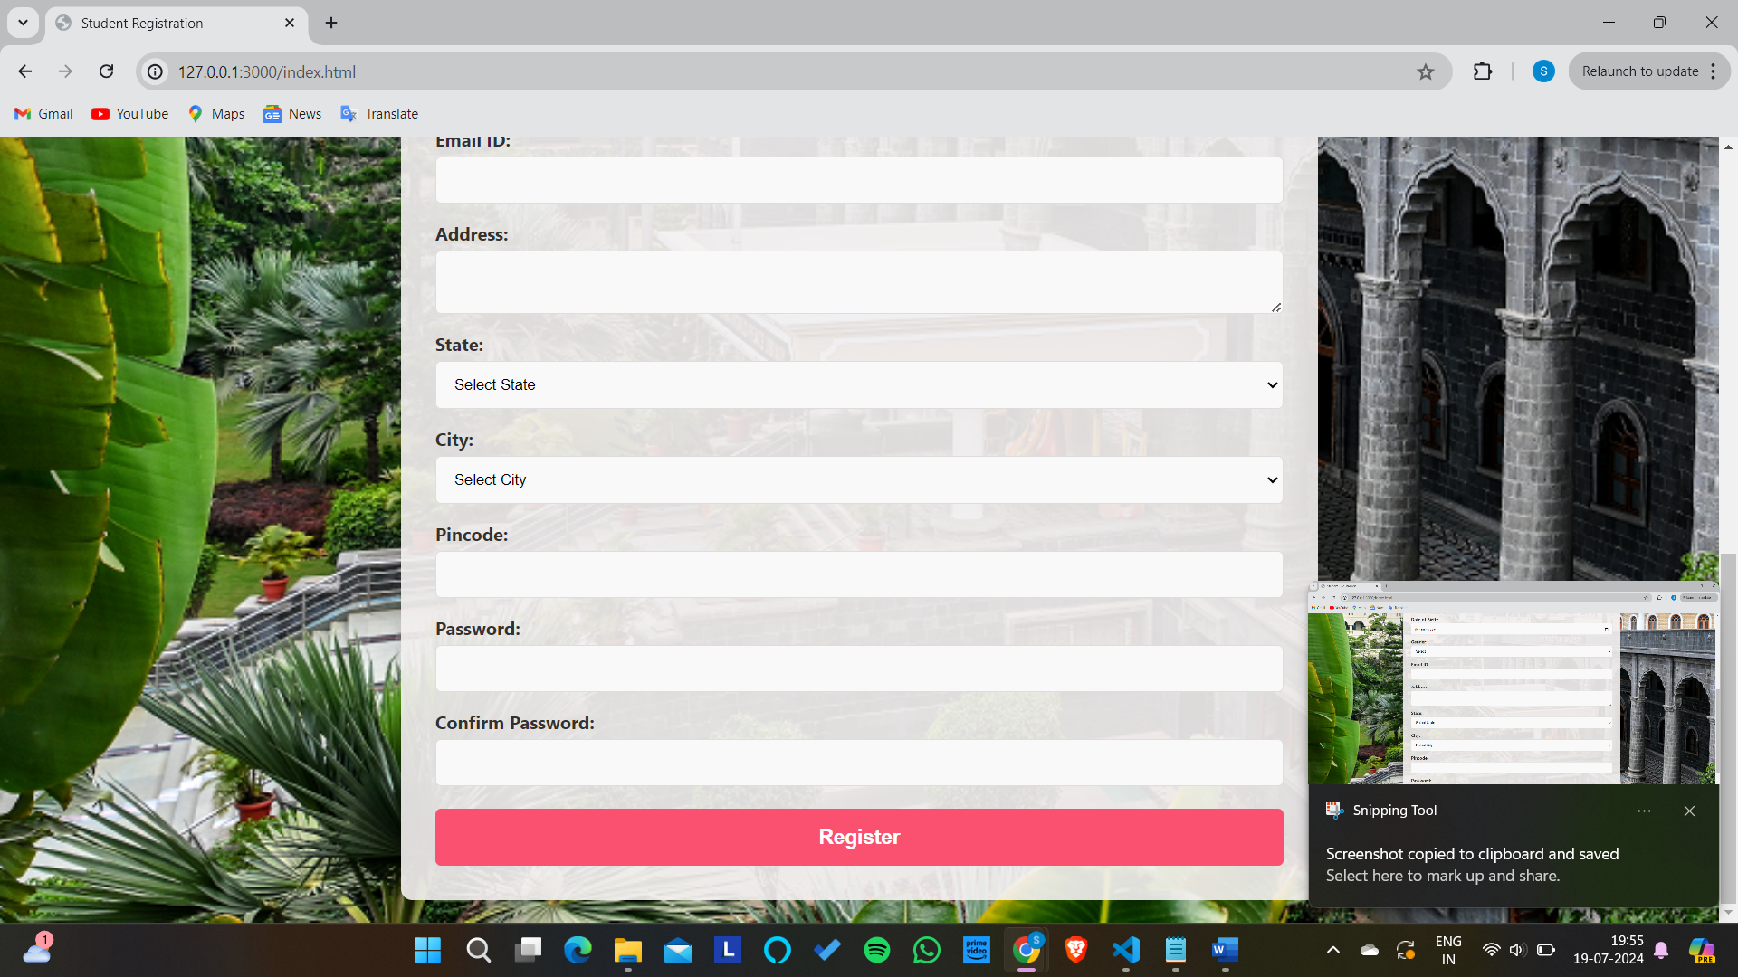

2. Entering details:

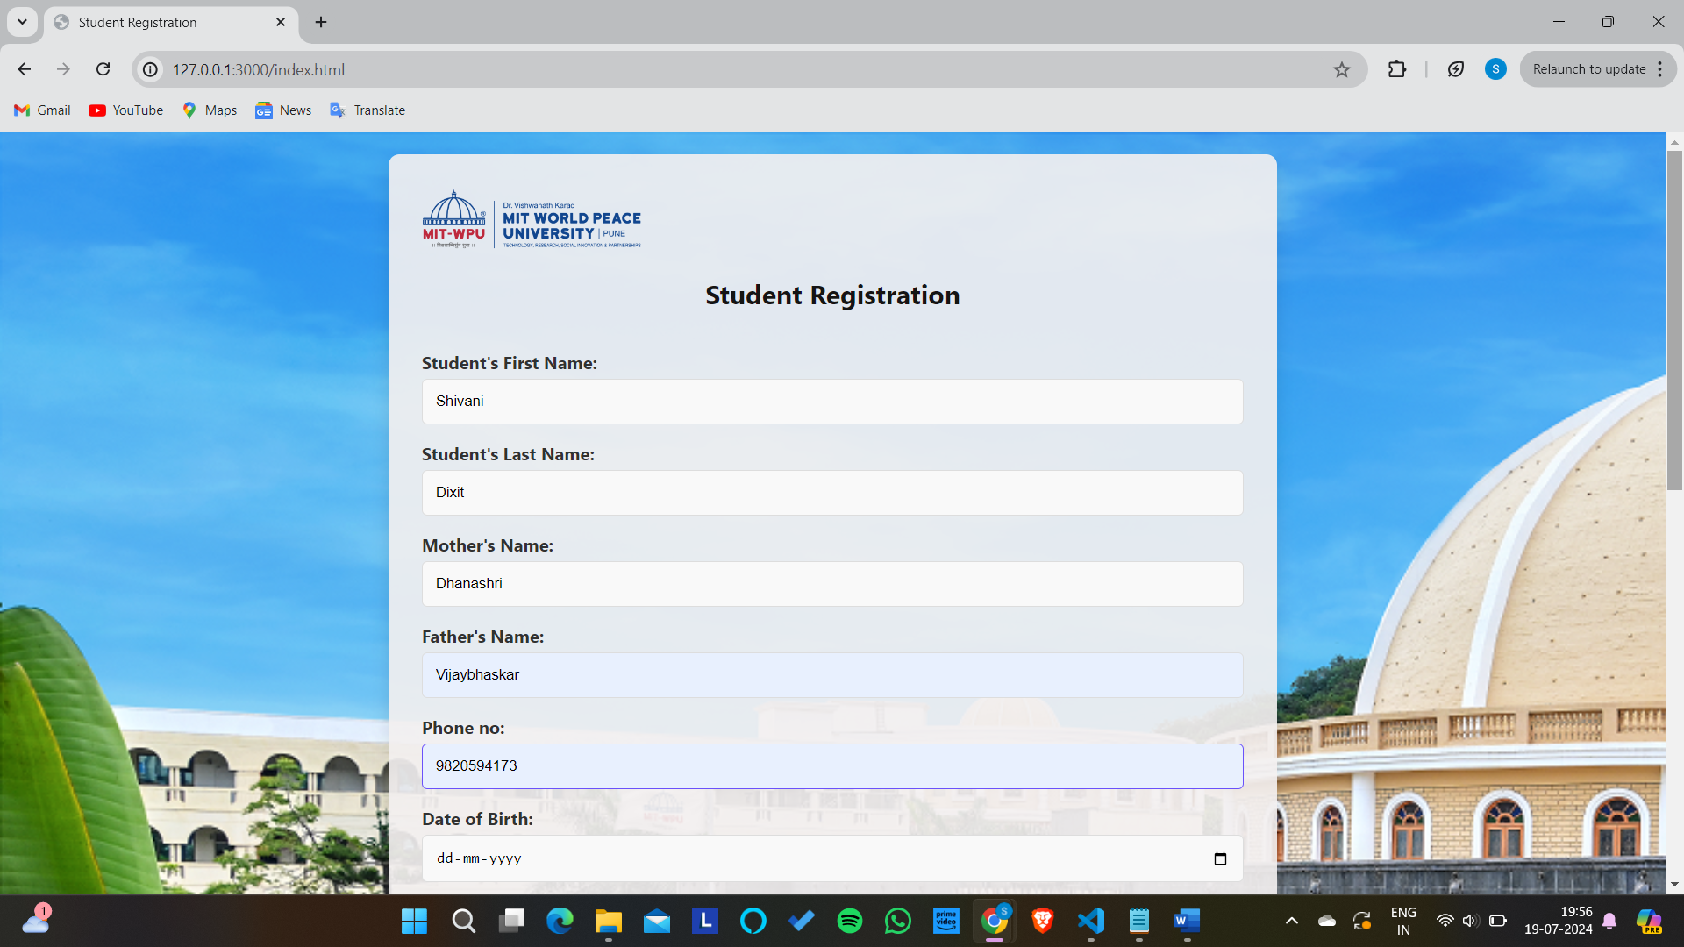

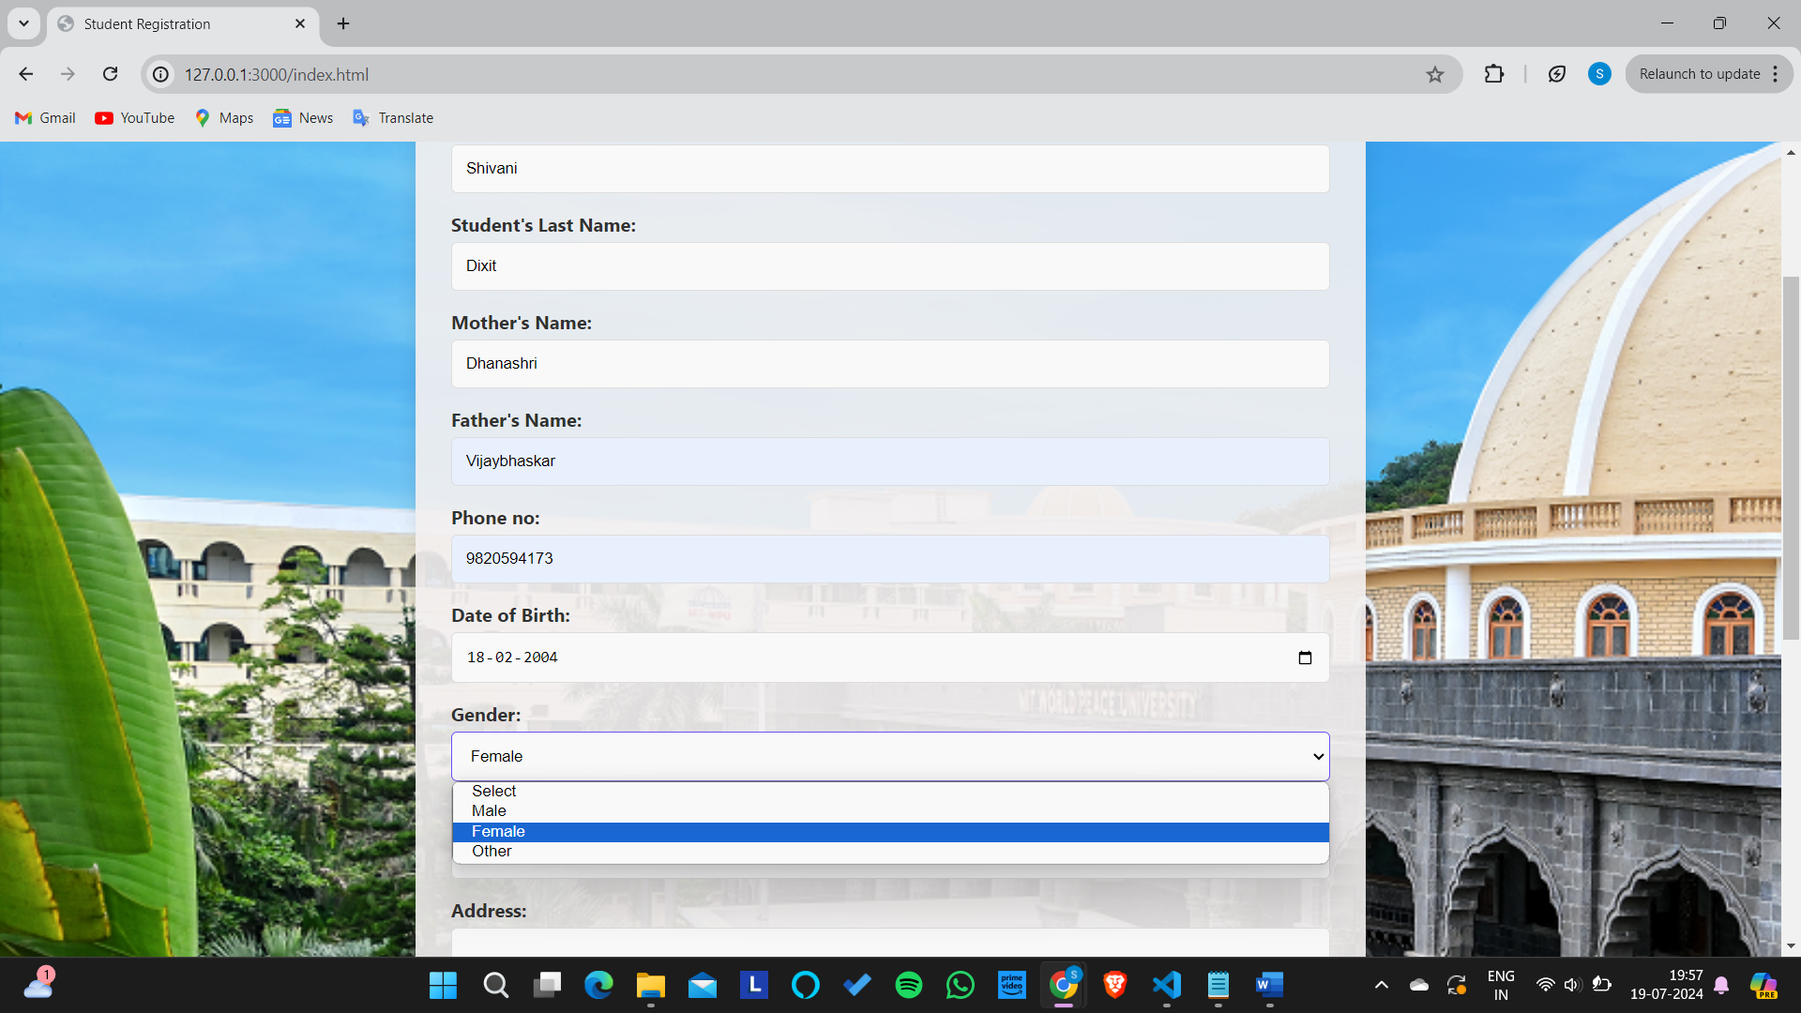

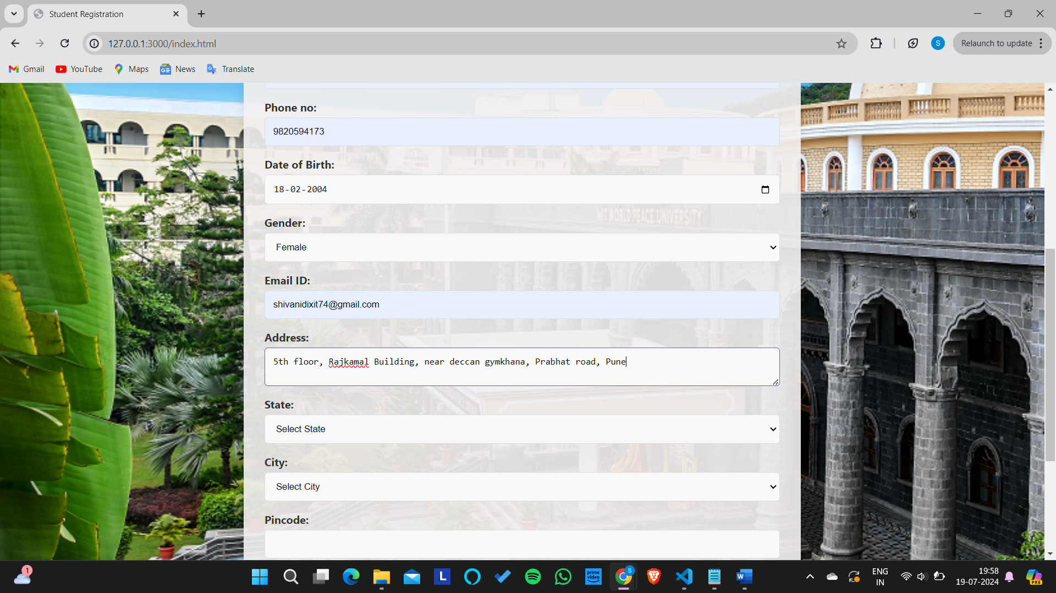

3.State dropdown:

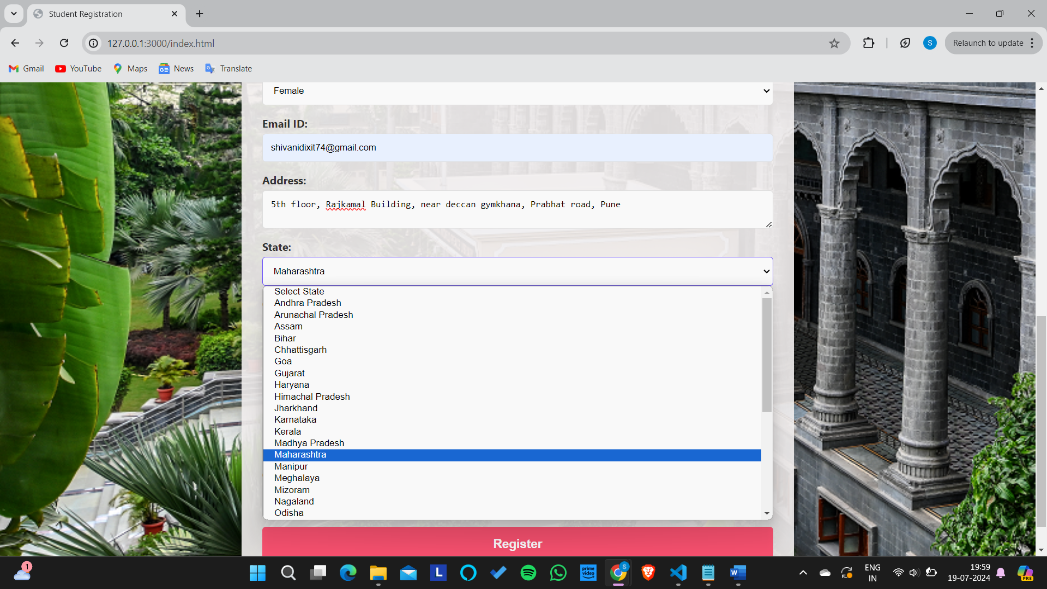

4. City dropdown

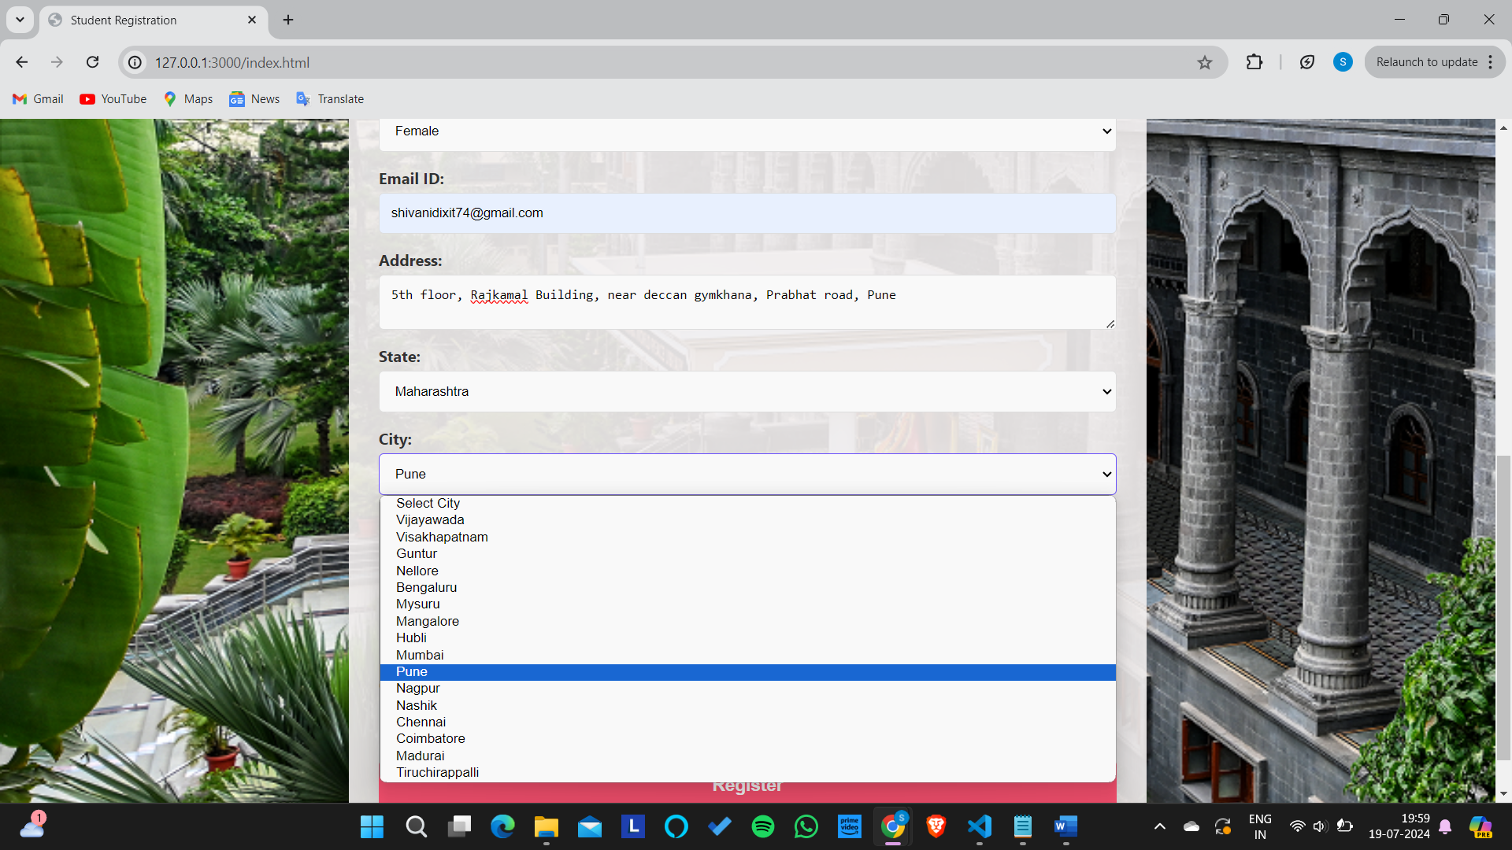

5. All details entered with the correct password:

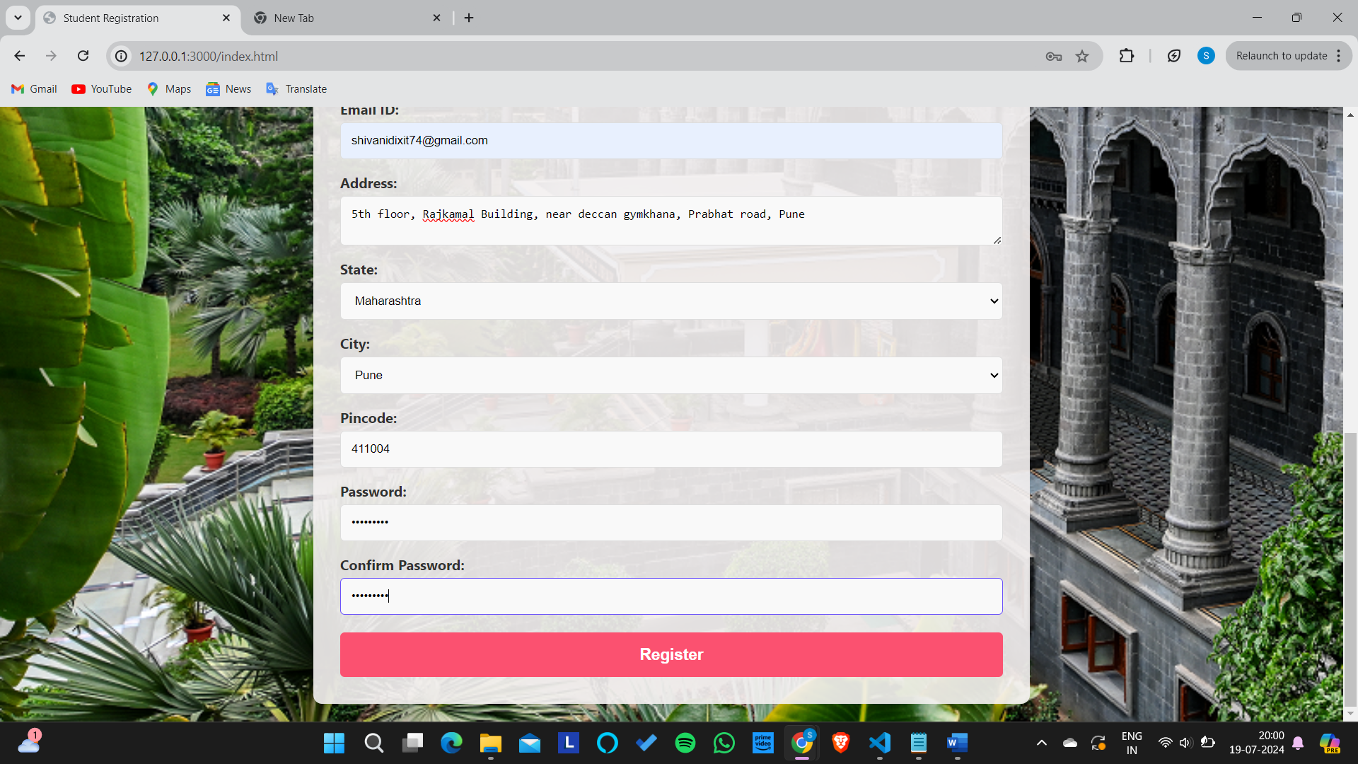

6. Registration button hover:

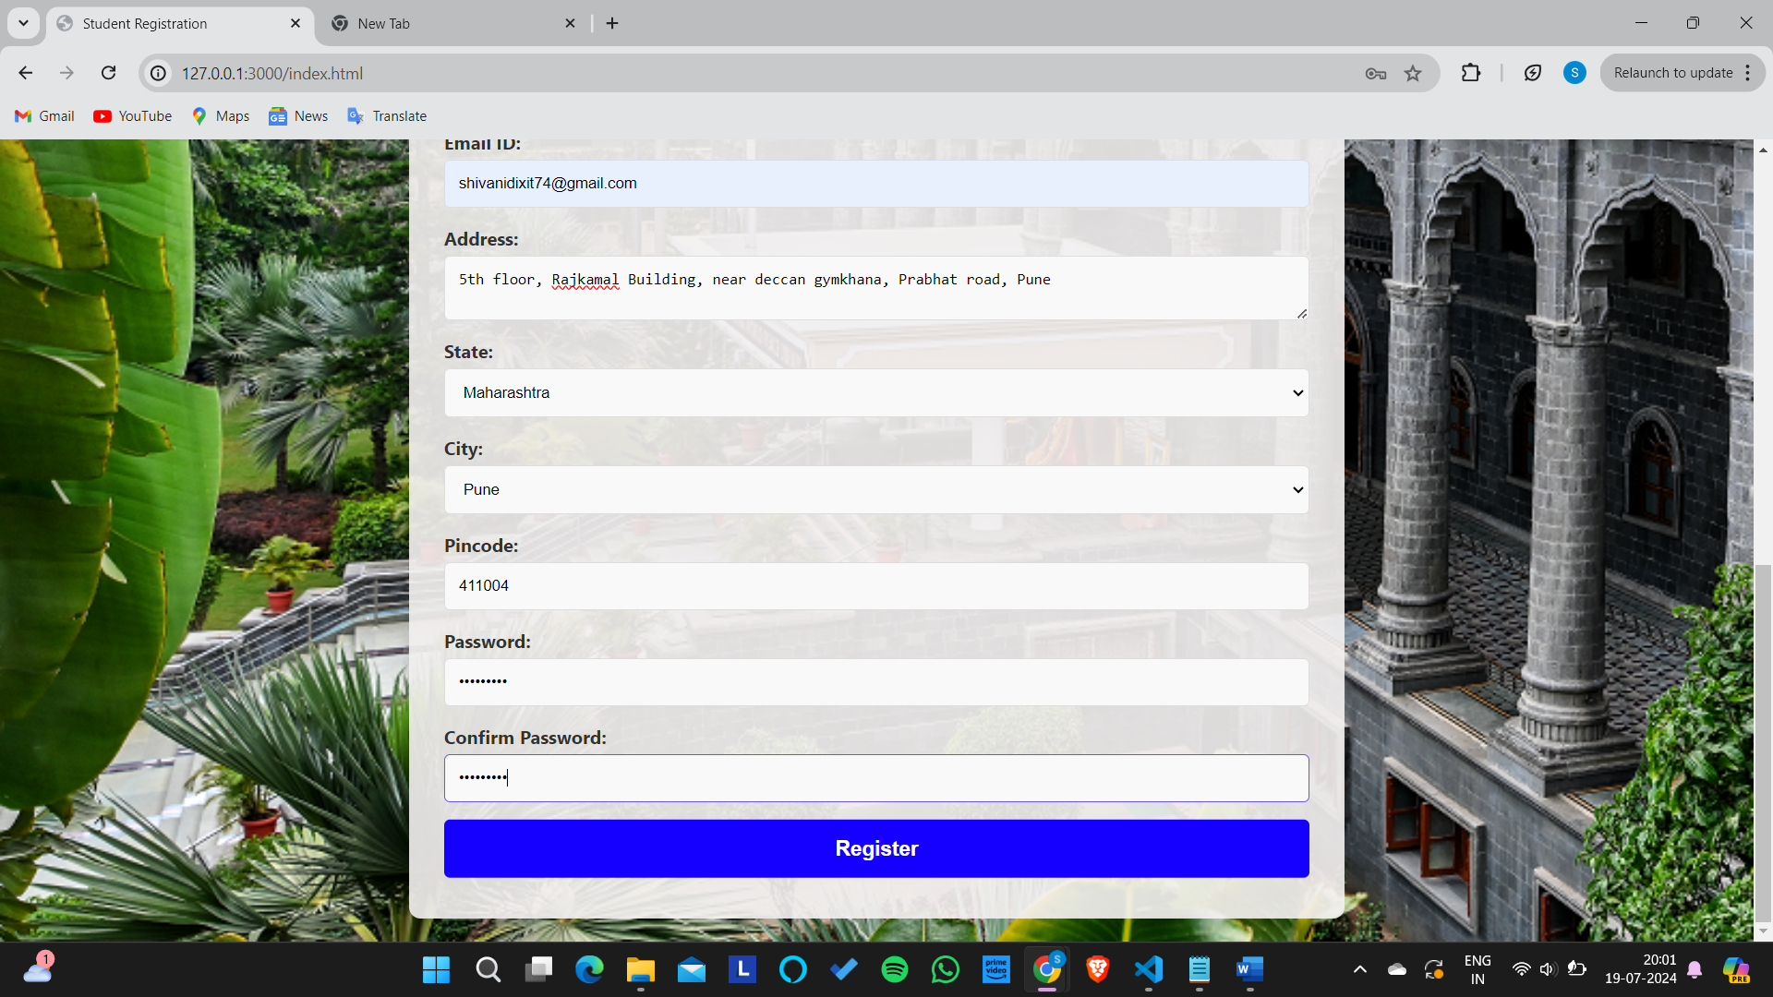

7. Alert showing Registration Successful when correct password entered

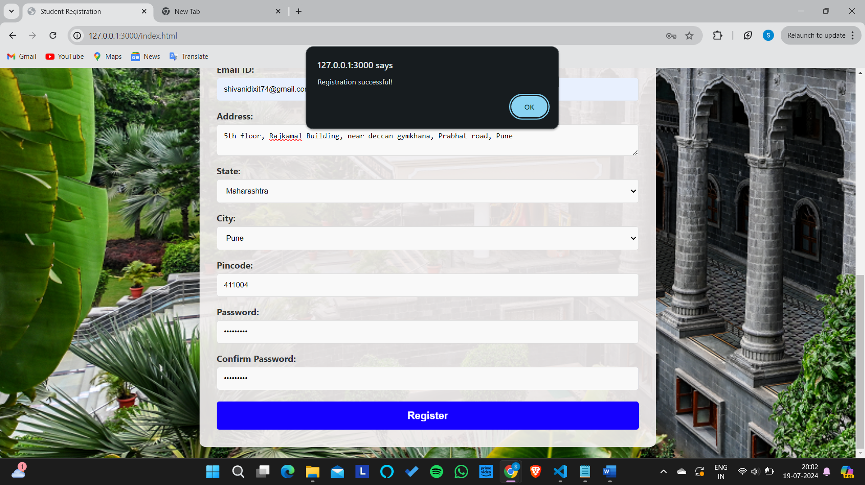

8. Entering numbers in names fields

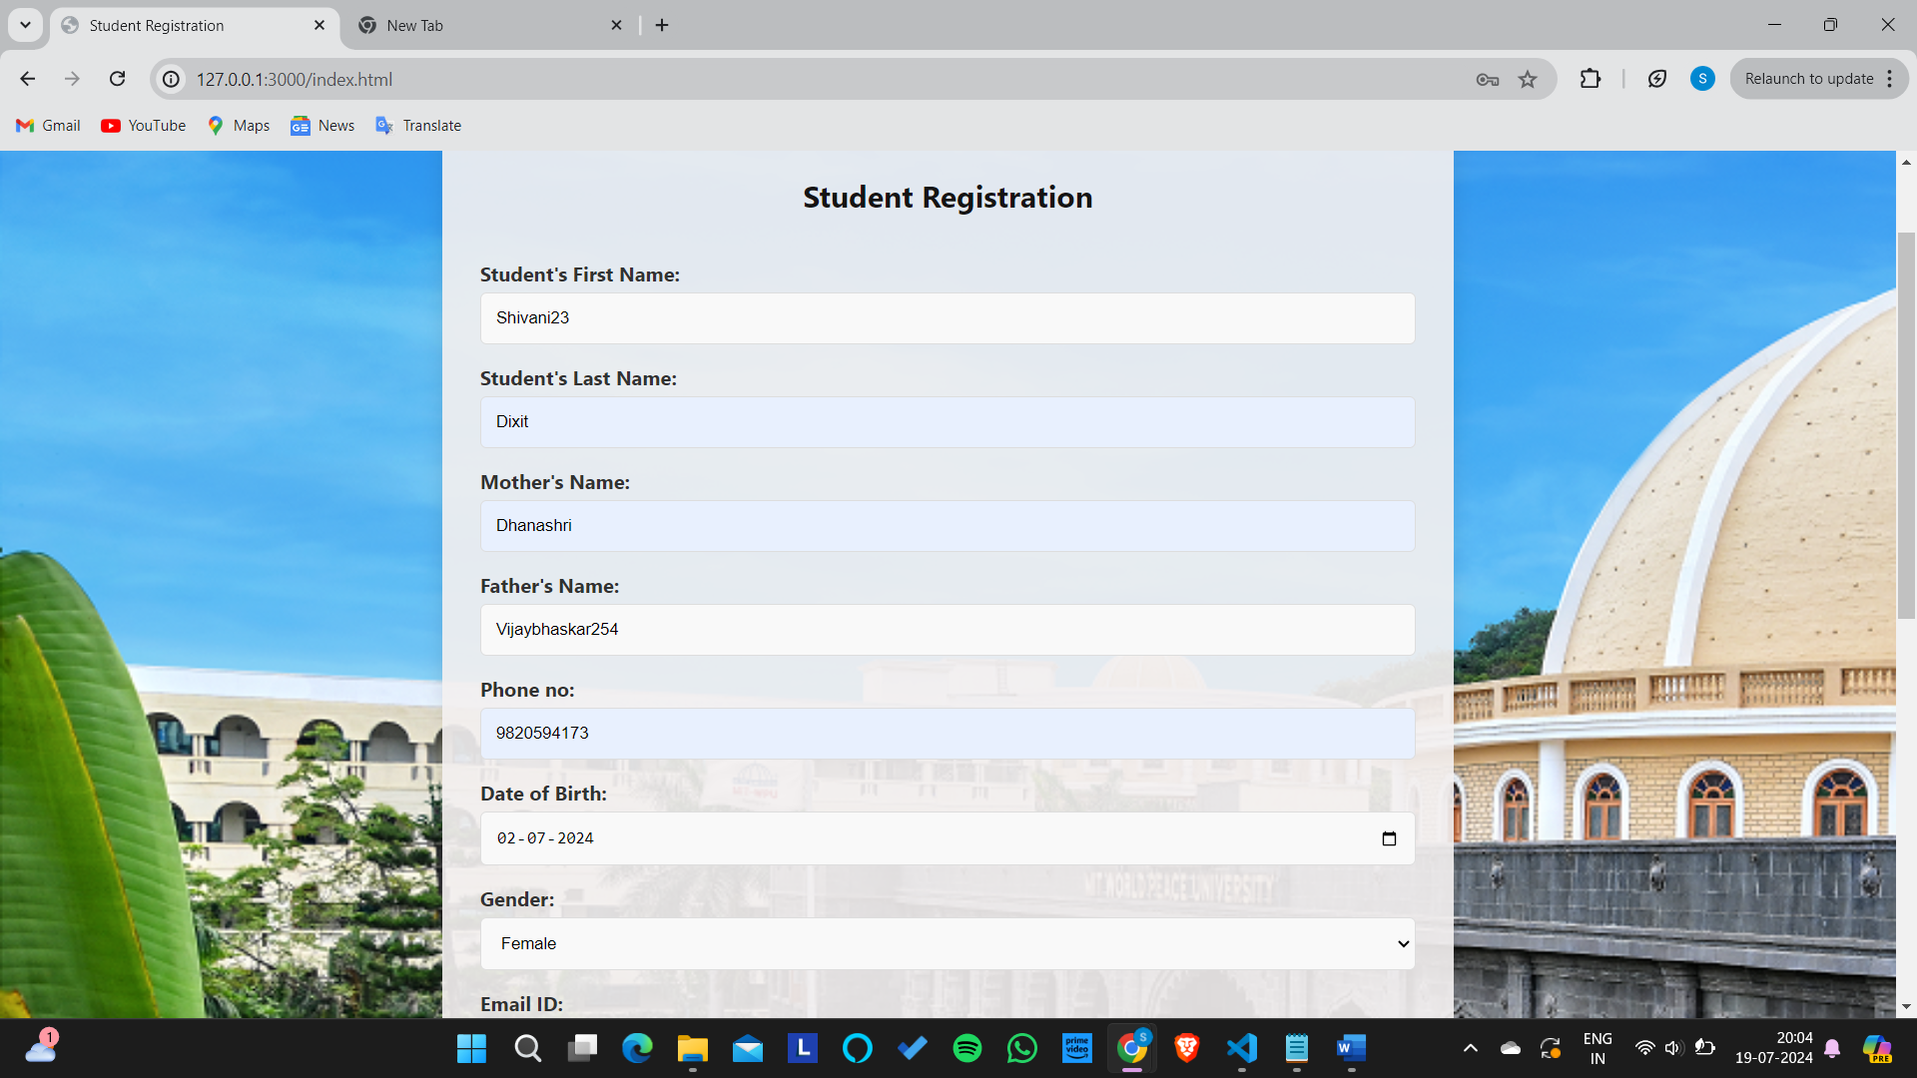

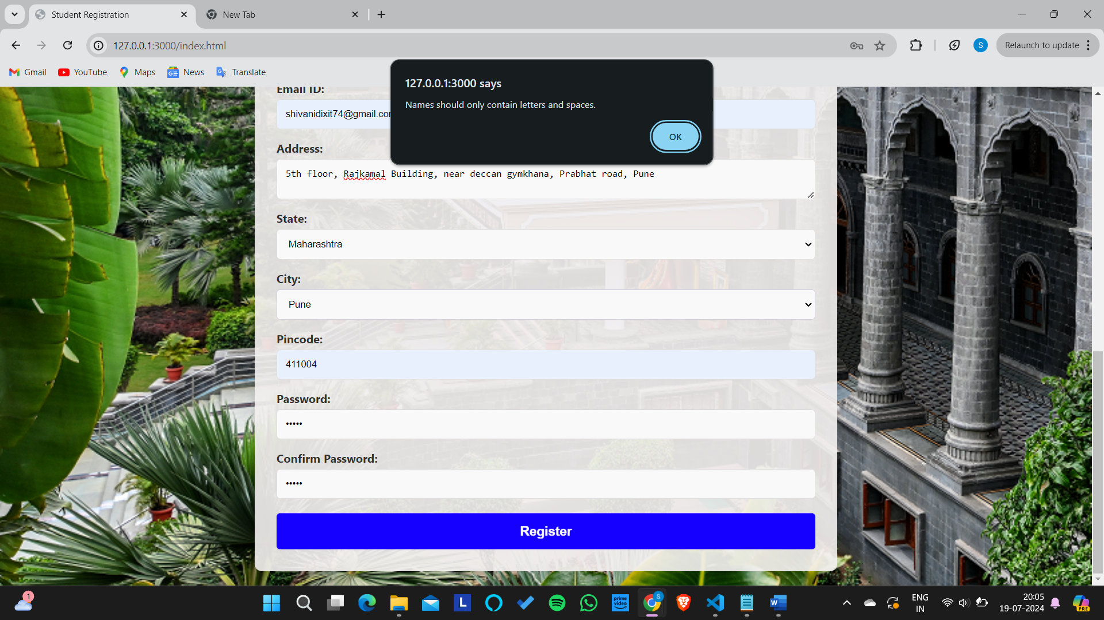

9. Passwords not entered correctly:

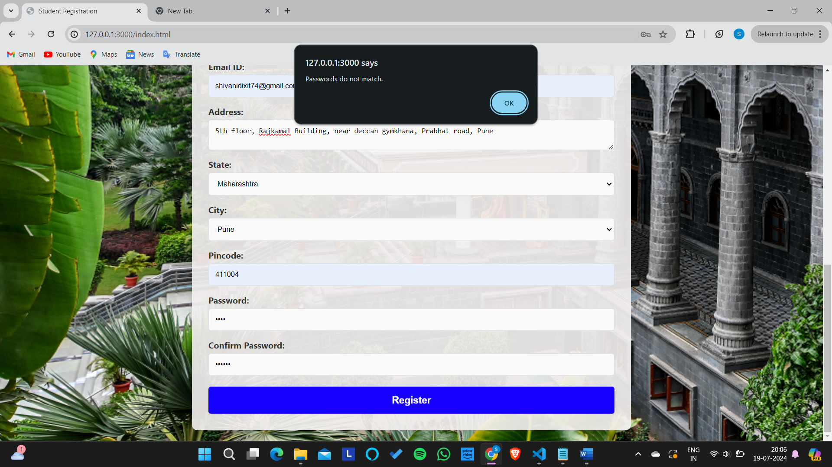

10. Form reset after registration successful message shown:

